**WKE FactoryView 2014 Pro **

Software that working with WK Instrument on Windows XP / 7 / 8 / 10, Professional, User friendly, Easy to use, Powerful

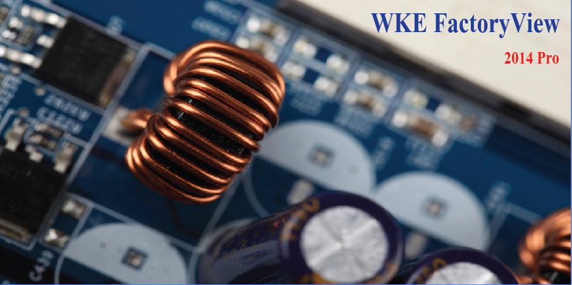

**FactoryView 2014 Pro working model**

|  |  |  |  |  |
| --- | --- | --- | --- | --- |
| **4100 series** | **4300 series** | **3260B** | **3255B** | **3265B（Q）** |
| **6440B** | **6430B** | **6500B** | **6500P** | **6565** |

**Login interface**

|  |  |
| --- | --- |
| We provide Chinese and English user interface, different test mode to fulfill different needs, and it can adapt different connection (GPIB LAN USB) |  |

**Meter Mode**

|  |  |
| --- | --- |
|  | Meter Mode:   * Multiple step test * Save / Load test procedure * Statistical analysis * Meter calibration * Choose and save the test parameter unit (Ex: uH) * Export CSV file, customizable divide symbol |

|  |  |
| --- | --- |
| It can accord to different steps, parameters to do Histogram and normal distribution data analysis. You can save the picture to file. |  |

|  |  |
| --- | --- |
|  | Meter Mode - Trigger:   * Multiple trigger type to meet different types of application scenarios * Options to choose save / display result, test index can be customized. * Fault tolerance setting * Export CSV file, customizable divide symbol |

Analysis Mode

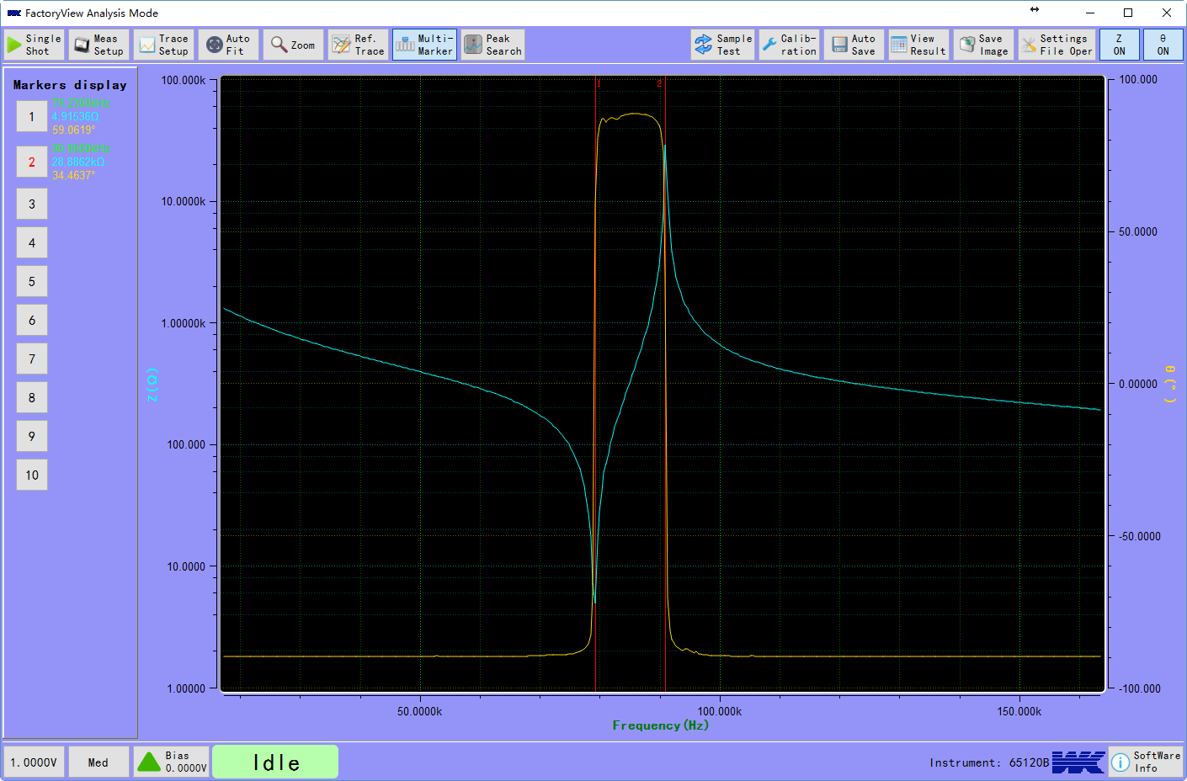

* Scan type: frequency, bias voltage, bias current, time
* Scanning spot can be automatically distributed or manually set
* Result curve automatic alignment
* Zoom in to result curve and scan specifically
* Up to 10 set of result curve for analysis, can load the previous test data
* Up to 10 set of cursor marks, and it can be dragged freely
* Peak search, you can search the maximum or minimum value of the curve
* Meter calibration, you can calibrate the instrument for compensation
* Test data is automatically saved
* Test data preview, Export CSV or EXCEL file, customizable divide symbol for CSV file
* Result curve can be saved in PNG format
* Test status display, you can change the test conditions during the test via the shortcut button
* Test profile management, you can save or load the test you needed
* Curve display can be turned on or off

|  |  |
| --- | --- |
|  | When the test parameters are impedance and phase angle, the test data can be exported into more data type, or even all of them. |

Export data:



**Resonance point search mode**

|  |  |
| --- | --- |
| Instrument: 6500B、6500P   * Searchable series and parallel resonant point * Adjustable searching speed * Lower and upper limit judgment for resonance point * Foot switch when using the ADU200 control box * Equivalent circuit model parameter will display after successful search |  |

**Multi-channel test (Must comply with the 20-channel test fixture)**

|  |  |
| --- | --- |
|  | Instrument : 6500 Series, 6440B, 6430B   * Dual frequency, four parameter can be set during the same test * Choose any channel for testing in the 20 channel * Channel switching delay can be set * Each channel can be calibrated separately using our unique calibration technology * Can do the calibration using the gold sample * Calibration data stored in the database, not necessary to calibrate each time * Support foot switch |

|  |  |
| --- | --- |
| * Cycle test data channels, each channel has separate data file with stamped * You can choose different test parameters for display * You can choose to display multiple channels of test data (0 to 20) * You can choose sampling delay * Displaying multiple channel only need one cycle time * Result curve can be saved in PNG format |  |

**Order code:**

WKE FactoryView 2014

**GLOBAL HQ:**

**Wayne Kerr Electronics**

Vinnetrow Business Park Tel: +44 1243 792200

Vinnetrow Road, Runcton Fax: +44 1243 792201